- OSI Layer

Q.1 Draw a diagram of the OSI 7-layer model and label each layer with its correct name and a real-world example of a device or protocol that operates at that layer (e.g., Switch at Data Link, HTTP at Application)?

Answer
- The OSI model has seven layers. Each layer performs a different function in network communication.
- Application Layer (Layer 7) – Example: HTTP / Web Browser
- Presentation Layer (Layer 6) – Example: SSL/TLS Encryption
- Session Layer (Layer 5) – Example: NetBIOS / RPC
- Transport Layer (Layer 4) – Example: TCP / UDP
- Network Layer (Layer 3) – Example: Router / IP
- Data Link Layer (Layer 2) – Example: Switch / Ethernet
- Physical Layer (Layer 1) – Example: Network Cable / Hub
The diagram above shows the correct order of all seven OSI layers along with a real-world device or protocol used at each layer.

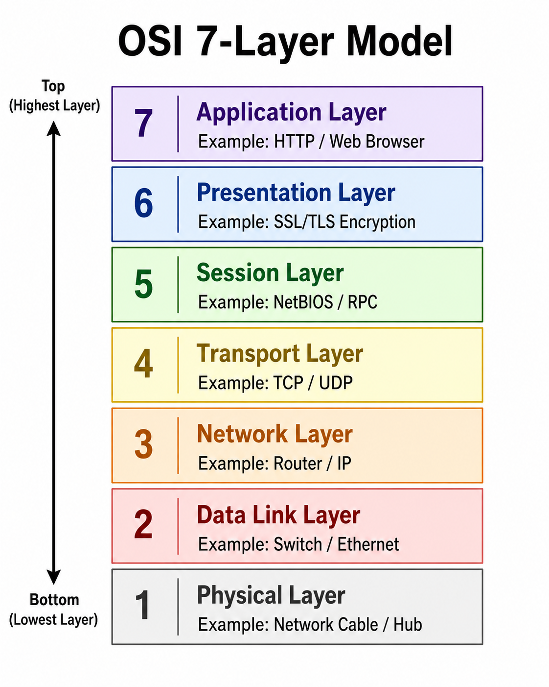

Q.2 Match the following networking scenarios to the correct OSI layer: a) Encrypting data before sending, b) Routing packets across networks, c) Converting data to electrical signals, d) Opening a web page in your browser, e) Detecting and correcting errors in frames.<br><br><em><strong>Hint:</strong> Write your answers as 'Scenario: Layer Name (Layer Number)'.</em>?

Answer
- Match the Networking Scenarios
a) Encrypting data before sending: Presentation Layer (Layer 6)
b) Routing packets across networks: Network Layer (Layer 3)
c) Converting data to electrical signals: Physical Layer (Layer 1)
d) Opening a web page in your browser: Application Layer (Layer 7)
e) Detecting and correcting errors in frames: Data Link Layer (Layer 2)

Q.3 Pick any app you use daily (like WhatsApp, Instagram, or Zomato) and describe how at least three different OSI layers are involved when you send or receive data in that app?

Anwer
- Example App: WhatsApp
When I use WhatsApp to send a message, different OSI layers are involved.
- Application Layer (Layer 7):
WhatsApp allows me to type, send, and receive messages.
- Transport Layer (Layer 4):
TCP helps send the data reliably from my device to the receiver.
- Network Layer (Layer 3):
IP helps route the data through different networks to reach the correct device.
- Data Link Layer (Layer 2):
Wi-Fi or Ethernet helps transfer the data inside the local network.

Q.4 Given this scenario: You are unable to access a website, but you can successfully ping its IP address. Identify which OSI layer(s) might be causing the problem and explain your reasoning?

Answer

- Website Access Problem
- If I cannot open a website but I can successfully ping its IP address, it means the Network Layer (Layer 3) is working because my device can reach the server.
- The problem may be in the Application Layer (Layer 7) because the web server or HTTP/HTTPS service may not be working.
- It may also be a Transport Layer (Layer 4) problem if TCP ports such as port 80 for HTTP or port 443 for HTTPS are blocked.
- So, the most likely problem is in the Application Layer or Transport Layer, because the server can be reached but the website cannot be opened.

